PHASE 2 – DATA FLOW DIAGRAM

Project Name: AI BlogNest API
Group No.: 6
Team ID: SWTID-2026-8851

Data Flow Diagram

The Data Flow Diagram represents the flow of user requests and data through the AI BlogNest API. The system uses Node.js and Express.js as the backend, MongoDB Atlas for data storage, JWT for authentication, and Gemini AI API for AI integration.

DFD Components

External Entity:

- User

Processes:

1. User Registration
2. User Login & Authentication
3. Blog Creation
4. AI Integration

Data Store:

- MongoDB Atlas

External System:

- Gemini AI API

Data Flows

- User → Registration → User Data → MongoDB Atlas
- User → Login → Authentication → JWT
- User → Blog Creation → Blog Data → MongoDB Atlas
- Blog/API Request → AI Integration → Gemini AI API
- Gemini AI API → AI Response → Backend/API → User
- MongoDB Atlas → Stored Data → Backend/API → User

Diagram Legend

- Rectangle: External Entity / System
- Circle or Rounded Rectangle: Process
- Cylinder: Data Store
- Arrow: Data Flow

Diagram

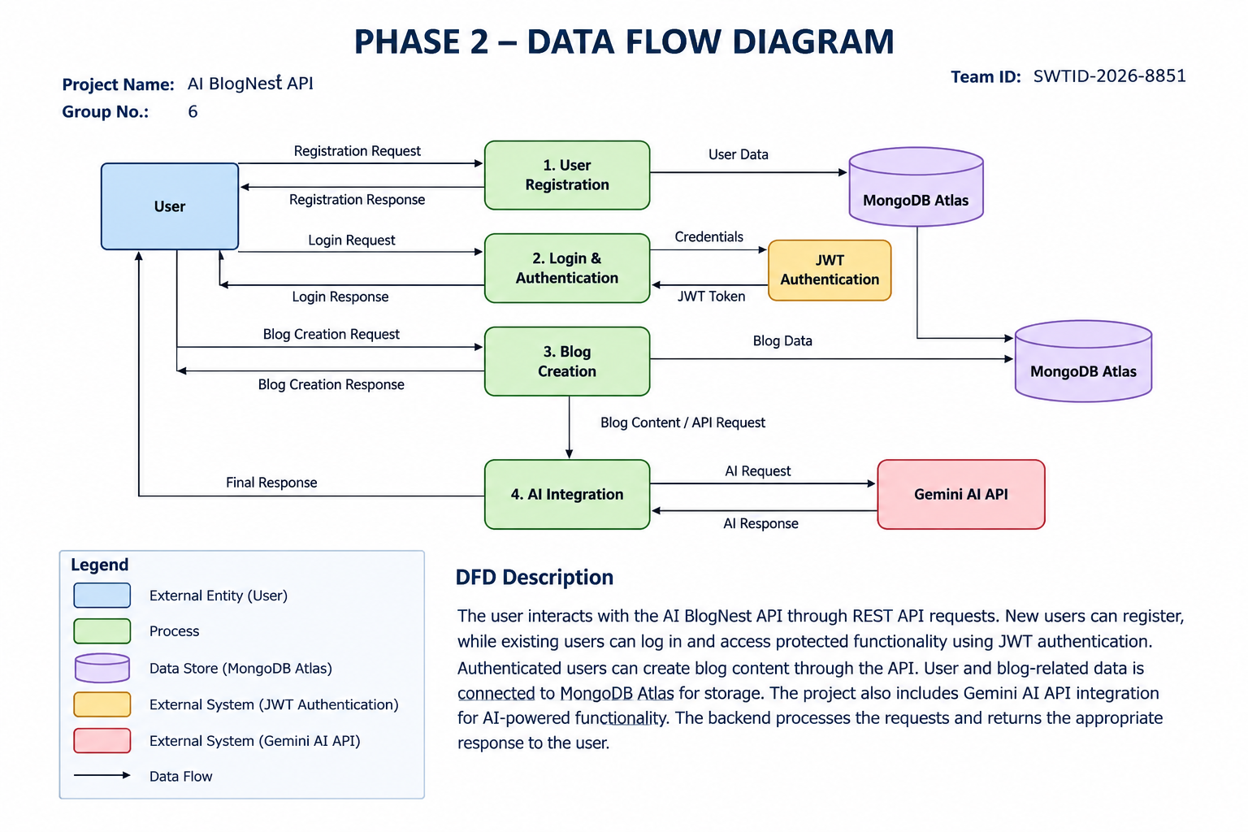

DFD Description

The user interacts with the AI BlogNest API through REST API requests. New users can register, while existing users can log in and access protected functionality using JWT authentication. Authenticated users can create blog content through the API. User and blog-related data is connected to MongoDB Atlas for storage. The project also includes Gemini AI API integration for AI-powered functionality. The backend processes the requests and returns the appropriate response to the user.

